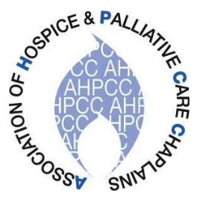
Association of Hospice &

Palliative Care Chaplains

Annual Conference 2021

Tuesday 18 May & Wednesday 19 May

A virtual event on Zoom

Reframing Spiritual Care in a Palliative Setting – Responding to Changing Times

We are inviting short videos on palliative care chaplaincy experiences in the pandemic. If you would like to participate, please see the AHPCC website*
Please put these dates and times in your diary
Day 1: 13.00 – 16.00 Including Heather Richardson
Day 2: 11.00 – 12.00 AHPCC AGM
13.00 – 16.00 Including Professor Max Watson

Heather Richardson is currently Joint CEO of St Christopher’s Hospice, London, and former National Clinical Lead for Hospice UK

Max Watson is the Director of Project ECHO with Hospice UK and consultant in palliative medicine for the Western Trust, Northern Ireland

Cost: Free for AHPCC Members / £10.00 to Non-Members

A conference addressing training needs for continuous professional development
CPD Points applied for

* www.ahpcc.org.uk

