AHPCC Conference 18 & 19 May, 2021. Biographies of participants.

Reframing Spiritual Care in a Palliative Setting – Responding to Changing Times.

Professor Max Watson - Keynote Speaker
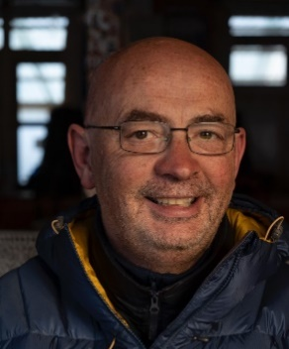
Max Watson trained in theology, medicine, and general practice. He has worked in Nepal for eight years as an ordained missionary with the Presbyterian Church in Ireland setting up a general practice education programme. He returned to Northern Ireland to complete training in palliative care in London and Belfast. Max is currently Director of Project ECHO with Hospice UK and consultant in palliative medicine in the Western Trust in Northern Ireland. Max is author and editor of many books and courses, including the Oxford Handbook of Palliative Care and the European Certificate in Essential Palliative Care.
He has taught across the world, particularly in India and Nepal, as well as in collaboration with the Aga Khan foundation in seeking to establishing palliative care services in different Islamic settings.
His research interests include generalist education, and end of life care in people with dementia. Current spiritual influencers include the Apostle Paul, Father Richard Rohr, Rumi, and Leonard Cohen.

Dr Heather Richardson - Keynote Speaker
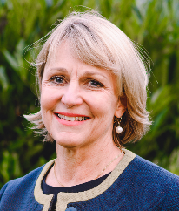
Heather Richardson works as one of the Joint CEOs of St Christopher’s Hospice, London. She has previously held the role of National Clinical Lead for Hospice UK, and worked as Clinical Director, then Strategy Advisor to St Joseph's Hospice in East London prior to her move at St Christopher’s. She has also worked as an associate with the Innovation Unit based in London.
Heather is a registered general and mental health nurse and has worked in hospice/palliative care since 1988. She has a PhD; her research concerned with users’ experience of day hospice. More recently she has developed a research interest around public health and end of life care. She currently serves as an honorary professor in palliative care at Lancaster University. In the past she has received the International Palliative Nurse of the Year award issued by the International Journal of Palliative Nursing and other awards related to her role in innovation in healthcare.

Tom Gordon – Conference Chaplain
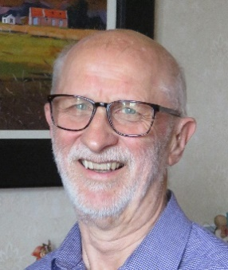
Tom Gordon was a parish minister in Edinburgh for twenty years and chaplain at the Marie Curie Hospice for fifteen. Now retired, he writes, teaches and facilitates bereavement support programmes.
His books cover: hospice chaplaincy; loss, grief and bereavement; contemporary parables (to parallel the Lectionary cycle); a ‘thought for the day’ for two full years (see www.ionabooks.com). A further book on bereavement is due this year. He is co-author of Spiritual Care for Healthcare Professionals with Ewan Kelly and David Mitchell.
He was the winner of the Scottish Arts Club member’s prize in their 2017 short story competition and of the Scottish Arts Trust’s Flash Fiction international prize in 2019. He is founder and facilitator of the Acorns and Stepping Stones bereavement support programmes in Edinburgh and East Lothian.

Bob Whorton – Conference Chaplain
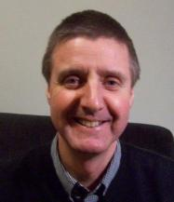
Bob Whorton is a Methodist Minister who has worked in circuit and in chaplaincies with in high-secure psychiatric settings and hospice. He now lives in western France where with his wife Sue he has set up a small reflection centre. His particular interest is in encouraging a reflective style in ministry using creative methods. Drawing on his experience of hospice chaplaincy, and writing honestly about his inner reactions to this work he has published Reflective Caring: Imaginative listening to Pastoral Experience (SPCK 2011) and Voices from the Hospice (SCM, 2015). With Karen Murphy, he has also edited Chaplaincy in Hospice and Palliative Care (Jessica Kingsley, 2017).
He continues to be fascinated by the process of pastoral supervision and has most recently worked as a lead trainer with the Methodist Church as it rolls out its supervision programme for those in ministry in the UK.

