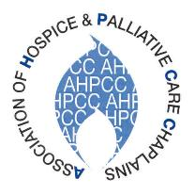

NOTICE OF AGM
1st April 2021
Dear AHPCC Member
Notice is hereby given that the Annual General Meeting of the Association of Hospice and Palliative Care Chaplains will be held on Wednesday 19th May 2021 at 11a.m. The meeting will be held through the medium of Zoom, prior to the start of the programme on the second day of the annual conference
In order to ensure that those who intend to join the meeting are actually AHPCC members, the webmaster’s instructions are as follows:
- Please respond to this email, if possible, by return, to margery.collin@gmail.com and no later than Thursday 13th May, indicating your intention to join the Zoom AGM meeting on 19th May at 11.00am.
- Following receipt of your email, papers for the AGM and a Zoom code link for the meeting will be sent to you by Friday 14th May.
- Margery will send your name and the name of your hospice to the webmaster who will let you into the meeting on Wednesday 19th. It is most important that your own full name shows up on the screen when you request entry to the meeting and not that of a colleague or family member or just ‘Ipad’ (Zoom allows you to make any alteration, if needed, as you sign in). If the webmaster doesn’t recognise your name from his list, he will decline your request to enter the meeting.
Thank you in anticipation of your help in making sure we have a successful AGM

Carol Gully
Carol Gully
AHPCC Secretary

