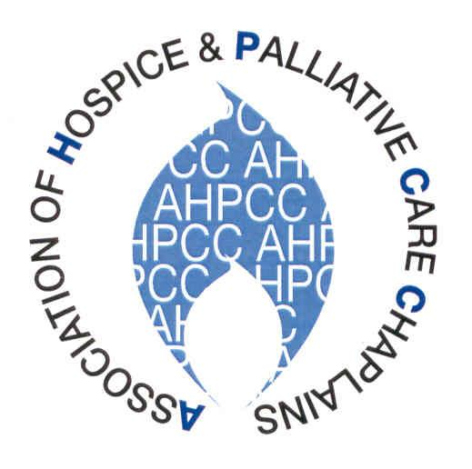
Annual General Meeting

Tuesday 24th May 2022
Hayes Conference Centre, Swanwick

Agenda

- Apologies for absence

- Minutes of AGM 2021

- Matters arising

- President’s Report: Keith Morrison

- Treasurer’s Report: Lucyann Ashdown

- Membership Report: Lucyann Ashdown

- Website: Mike Rattenbury

- Reports from other representatives, including:
- NI healthcare Chaplains Association (NIHCA) – John Wonnacott
- Scotland- Mike Rattenbury

- External Reports

- UKBHC
- Chaplaincy Forum
- European Network of Health Care Chaplains (ENHCC)

- Elections to the Executive

- Any Other Business

- Date of next conference- 15-17 May 2023

