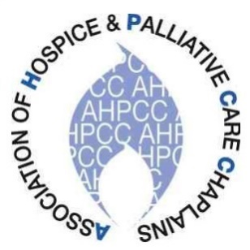

Carol Gully
carol.gully@ahpcc.org.uk

16 April 2023

To members of the Association of Hospice and Palliative Care Chaplains
I am writing to give formal notification of the Annual General Meeting of the Association of Hospice and Palliative Care Chaplains, which will take place on Tuesday, 16th May in the late afternoon, during our conference at the Hayes Conference Centre, Swanwick, Derbyshire (15–17th May 2023). Full papers will be provided on the day and also posted on the website.

I WOULD BE GRATEFUL IF MEMBERS COULD INFORM Carol Gully OF ANY ITEMS TO BE RAISED UNDER ‘ANY OTHER BUSINESS’, BEFORE THE EVENING OF MONDAY 8TH MAY. Her contact details are above.
Best wishes
Carol Gully
AHPCC Secretary

